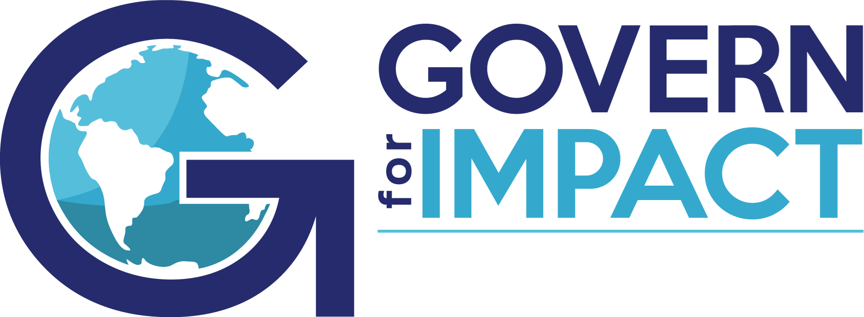

Municipal Government & Agencies Learning Community
Brainstorming a Work Plan: Themes and Topics
(last updated 3.24.23)

Themes & Topics:
- Monitoring Best Practices: Interpretations and Evidence, Public or Private?
- Performance Evaluation of CEO
- Ends in the Municipal Environment
- Challenges with Election/Political Pressures
- Linking with Residents/Voters
- Governance by Field (water, munis, transport...)
- Public Meetings requirements (post COVID)
- Maintaining commitment to PG
- Public scrutiny/visibility/push back
- Onboarding new CEO (board members?)
- Balancing short-term/long-term performance and commitments

