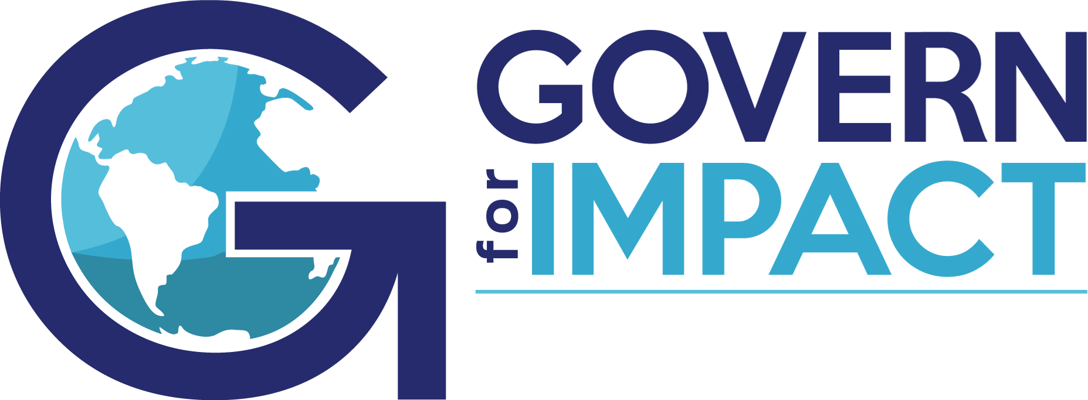

Municipal Government & Agencies Learning Community
Meeting #2: March 23, 2023
4:00 – 5:00 pm Eastern

In attendance:
Karen Fryday-Field, Matt Carpenter, Debra Hess, Douglas Efferson, Scott Garrison, Laurel Corbiere, Michael Mucha, Aimee Wade, Dan Blankenship, Jeremiah Dameron

High-level Overview and Takeaways:

- Each participant shared history about their organization, as well as one opportunity and one success related to Policy Governance.
- Group confirmed ideas/themes to tackle that were shared in the first meeting, and made some additions. Full list of ideas themes includes:
- Monitoring Best Practices: Interpretations and Evidence, Public or Private?
- Performance Evaluation of CEO
- Ends in the Municipal Environment
- Challenges with Election/Political Pressures
- Linking with Residents/Voters
- Governance by Field (water, munis, transport...)
- Public Meetings requirements (post COVID)
- Maintaining commitment to PG
- Public scrutiny/visibility/push back
- Onboarding new CEO (board members?)
- Balancing short-term/long-term performance and commitments

Learning Community Agreements and next steps:
- No recording of sessions. The richness and knowledge will come from the conversation in real time. Quick summary/bullet points of topics covered and next steps is helpful, but no written/recorded full recap is needed.
- 4 – 5pm Eastern is a good general time. 1x per quarter on Thursdays (4th or 5th Thu of each month) works for most people.
- Monitoring will be first topic for deeper dive in our next meeting.
- Use the Forums and online features available on the GOVERN for IMPACT website as a place to share comments, thoughts, and examples. (Jeremiah Dameron, Director of Affiliate Services, is a resource and can assist: jdameron@governforimpact.org)

